Installing GlobalSight on Ubuntu

GlobalSight version 7.1.8
Ubuntu version 8.04 LTS
Open source initiative for
managing, translating &
delivering global content

Copyright © 2010 Welocalize, Inc.

Table of Contents
Table of Contents 1
Pre-requisites 3
Installing the GlobalSight files 4
Configuring the OpenLDAP Directory Server 30
Configuring GlobalSight Web Services (optional) 32
Installing the Aligner (optional) 33
Pre-requisites 33
Installation 33
Configuring Samba (optional) 34
Converters for Windows (optional) 36
Pre-requisites 36
Server 36
Hardware 36
Operating System: Microsoft Windows XP/2003 Server 36
Additional Software For Converters 36
Installing the MS Office Converters 38
Install .NET Framework 2.0 38
Installing the MS Word Converter Service 38
Error Logs 39
Uninstall 40
Installing the ADOBE InDESIGN & ILLUSTRATOR Converter 41
Installing the InDesign and Illustrator Converter 41
Set Converter 41
Error Logs 41
Uninstall 41
Installing the Desktop Publishing Converters 42
Pre-requisites for the Adobe FrameMaker Converter 42
Installing the FrameMaker Adapter 42
Edit the Pyxis Initialization File 44
Edit Regedit for FrameMaker Adapter. 47
Test the GlobalSight – Pyxis Integration for FrameMaker7 47
Installing ContentManager (optional) 49
Pre-requisites 49
Integrating ContentManager 49
Configuring Mediasurface 49
Configuring GlobalSight 51
Setup 52
Setting up a user 52
Importing a file into GlobalSight 52
Configuring GlobalSight for Auto-Import (optional) 53
Pre-requisites 53
Set Auto-Import Parameters 53
Specifying directories to watch 54
Preparing documents for import 56
Start and stop procedure 57
Start GlobalSight in Service Mode 57
Stop GlobalSight in Service Mode 57
Start GlobalSight in Console Mode 57
Stop GlobalSight in Console Mode 57
Logging in to GlobalSight 58
Uninstalling GlobalSight 59
Uninstall the Application Service 59
Uninstall the OpenLDAP Directory Server 59
Uninstall JDK 59
Uninstall MySQL 59
Cleanup the system PATH variable 59

Pre-requisites
Install third-party components before installing GlobalSight. For instructions, see the GlobalSight 3rd Party Components for Ubuntu document.
The user needs to have sudo privileges.
Download and unzip the GlobalSight Software Package for Linux from www.globalsight.com. and unzip the package:
Type: jar xvf GlobalSight_Software_Packages_Linux.zip
Unzipping creates the following folders:
- 3rd_party_software
- Aligner
- Converters
- DesktopIcon
- Documentation
- GlobalSight
Note that Internet Explorer (IE) is the only browser fully supported at the moment.

Installing the GlobalSight files
- Ensure that $JAVA_HOME is in your PATH
For example: echo $JAVA_HOME
/usr/local/java/jdk1.6.0_07
For example: echo $PATH
/usr/local/sbin:/usr/local/bin:/usr/sbin:/usr/bin:/sbin:/bin:/usr/X11R6/bin:/usr/local/mysql/bin:/usr/local/java/jdk1.6.0_07/bin:/usr/local/openldap/sbin
- Ensure that <MySQL_ROOT>/bin is in your PATH and that you can access the GlobalSight MySQL Server from the MySQL command line. This GlobalSight installer uses this to connect to the MySQL database server to create tables for the GlobalSight application.
For example: echo $PATH
/usr/local/sbin:/usr/local/bin:/usr/sbin:/usr/bin:/sbin:/bin:/usr/X11R6/bin:/usr/local/mysql/bin:/usr/local/java/jdk1.6.0_07/bin:/usr/local/openldap/sbin
- Create a user called “jboss” for the GlobalSight system as follows:
Type: sudo useradd jboss
Type: sudo usermod -a -G jboss jboss
Type: sudo usermod -s /bin/bash jboss
Type: sudo mkdir /home/jboss
Type: sudo chown -R jboss:jboss /home/jboss
Type: sudo passwd jboss
- Set the file attribute for the jboss user as follows:
Add a file named “.profile” under the directory /home/jboss
Type: cd /home/jboss
Type: sudo vi .profile
Add the content below to this file:
umask 002
Set .profile ownership
Type: sudo chown jboss:jboss .profile
- Copy the GlobalSight_7.1.zip to /home/jboss directory and unzip it under /home/jboss directory
Type: jar xvf GlobalSight_7.1.zip
- If you want to create a start service for GlobalSight, switch to the user with sudo privileges
Switch to the user with (e.g. root) the sudo privilege or sudo to root:
Type: sudo -i
- Go to the installation directory (e.g. /home/jboss/GlobalSight_7.1/install) and add the executable attribute to the file Install.sh as follows:
Type: cd /home/jboss/GlobalSight_7.1/install
Type: chmod u+x Install.sh
Run the Install.sh
Type: sudo PATH=$JAVA_HOME/bin:$PATH ./Install.sh
The GlobalSight Installation interface starts.
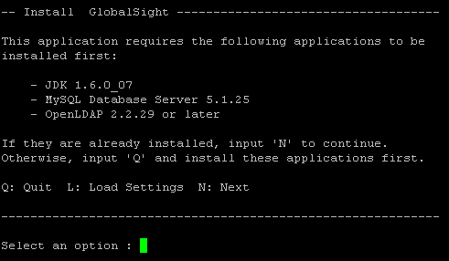

- In the Install Menu, type N to go to the next page
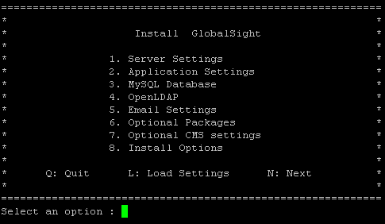
- In Server Settings, enter the installation parameters as required
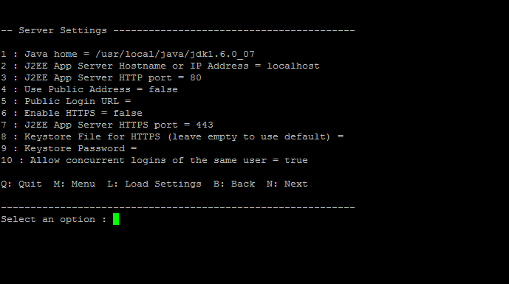
To set the value for the options, first select the index of the option and then input the value.
Use the table below for help with the installation parameters.
Parameter | Description
Java home | The JAVA_HOME to run the application server
J2EE App Server Hostname or IP Address | The name of the server on which you installed the Application Server. Enter the fully qualified name of the host, for example, machine.domain.com or localhost  Default: localhost
J2EE App Server HTTP port | The web server HTTP port for the App Server  Default: 80  Note: Use a port number higher than 1024  On UNIX-type operating systems, only user root can bind to listen on port 80. All other users are considered non-privileged and they cannot bind to that port. In fact, all ports below port 1024 are considered privileged. This is a basic security measure.
Use Public Address | Flag (true or false) to use a public address for the Application Server to log in  Default: false
Public Login URL | The public login URL for the Application Server
Enable HTTPS | Flag (true or false) to enable HTTPS for the Application Server  Default: false
J2EE App Server HTTPS port | The web server HTTPS port for the App Server  Default: 443
Keystore File for HTTPS(leave empty to use default) | The keystore file for HTTPS authentication  Default: empty. Default self-signed certificate
Keystore Password | The keystore file’s password for HTTPS authentication  Default: empty. Default self-signed certificate’s password: changeit
Allow concurrent logins of the same user | Flag (true or false) to allow concurrent logins of the same user. If set to false, you cannot login twice (concurrently) with the same username. If you want to login as the second user, the first user must log out or you must wait for their session to time out.  Default: true
- Type N to go to the next page

- In Application Settings, enter the information required:
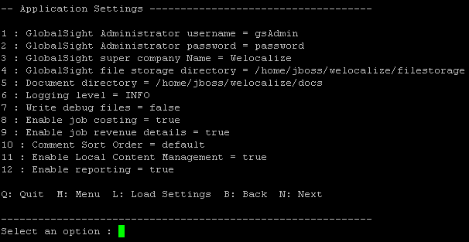
Use the table below for entering the installation parameters.
Parameter | Description
GlobalSight Administrator username | The user used for first login to GlobalSight and for creating all other users initially. This user is created in OpenLDAP when importing the globalsight.ldif file below  Default: gsAdmin
GlobalSight Administrator password | The password of the GlobalSight Administrator username  Default: password
GlobalSight Super Company Name | The name of the super company of GlobalSight  Default: Welocalize
GlobalSight file storage directory | This is a permanent directory that GlobalSight uses to store temporary files.  Note: The jboss user must have the write privilege to the directory you choose
Document directory | his is where the files are imported from and exported to.  Note: The jboss user must have the write privilege to the directory you choose
Logging level | This means the Debugging level.  Default: INFO
Write debug files | Flag (true or false) to enable writing to the debug directory  Default: false
Enable Job Costing | Flag (true or false) to enable the Job Costing feature  Default: true
Enable job revenue details | If this module has been purchased, then answer “true”. Otherwise answer “false  Default: true
Comment Sort Order | Default: default
Enable Local Content Management | Flag (true or false) to enable the Local Content Management feature  Default: true
Enable reporting | Flag (true or false) to enable the Reporting feature of GlobalSight  Default: true
- Input N to go to the next page

- In MySQL Database, enter the parameters required
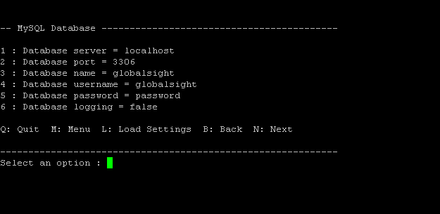
Use the table below for entering the installation parameters.
Parameter | Description
Database server | The server name or the IP where MySQL is installed  Default: localhost  For example: db_server.domain.com or 192.168.29.29 or localhost
Database port | The MySQL port  Default: 3306
Database name | The name of the GlobalSight database that you want to connect to  Default: globalsight
Database username | The GlobalSight database username, for example, GlobalSight  Default: globalsight
Database password | The password for the database user above  Default: password
Database logging | Flag (true or false) to enable the logging of SQL statements of hibernate and other database related information  Default: false
- Type N to go to the next page

- In OpenLDAP, enter the required parameters
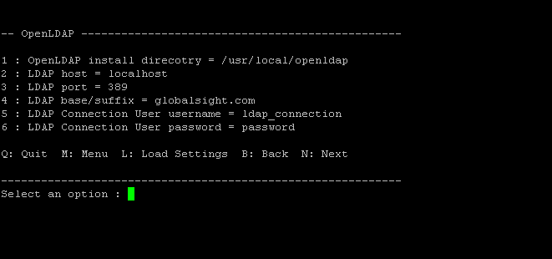
Use the table below for entering the installation parameters.
Parameter | Description
OpenLDAP install directory | The directory where OpenLDAP is installed  For example: /usr/local/openldap
LDAP host | The server name where OpenLDAP is installed. Use the fully qualified machine name, or just localhost  Default: localhost
LDAP port | OpenLDAP port  Default: 389
LDAP base/suffix | The domain name used when installing OpenLDAP to specify its base or suffix. For example, domain.com or globalsight.com  Default: globalsight.com
LDAP Connection User username | The OpenLDAP user that GlobalSight uses to connect to and communicate with OpenLDAP internally. This user is created in OpenLDAP when importing the globalsight.ldif file below  Use the default value  Default: ldap_connection
LDAP Connection User password | The password for the OpenLDAP user above  Default: password
- Type N to go to the next page

- In Email Settings, enter the information required
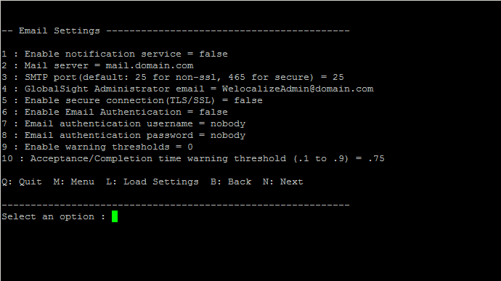
Use the table below for entering the installation parameters.
Parameter | Description
Enable notification service | Flag (true or false) to enable the Email Notification feature of GlobalSight  Default: false
Mail server | The mail server, for example mail.domain.com  Default: mail.domain.com
SMTP port(default: 25 for non-ssl, 465 for secure) | The SMTP port for the mail server  Default: 25
GlobalSight Administrator email | The email address of the GlobalSight administrator. When something goes wrong in the system, this person gets an email  Default: WelocalizeAdmin@domain.com
Enable secure connection(TLS/SSL) | Flag (true or false) to enable secure connection  Default: false
Enable Email Authentication | Flag (true or false) to enable the Email Authentication feature of GlobalSight. This feature should be enabled only when the mail server used by GlobalSight requires authentication  Default: false
Email authentication username | The mail server user that is used to authenticate all email sent from GlobalSight. This is a special mail server user created just for GlobalSight email authentication purposes. You must add this user to the mail server that you specified above  Note: The username is not the username of the sender of GlobalSight email, since GlobalSight emails can be sent from multiple users  This parameter is ignored if the Enable Email Authentication parameter above is disabled  Default: nobody
Email authentication password | The password for the email authentication user above  This parameter is ignored if the Enable Email Authentication parameter above is disabled  Default: nobody
Enable warning thresholds | This enables Job Acceptance/Completion/ warning thresholds.  Default: false
Acceptance/Completion time warning threshold | The time when the Acceptance or Completion warning email should be sent. The value is the time elapsed in percent between:  1. Job Creation and Acceptance  2. Job Acceptance and Job Completion  This parameter is ignored if the Warning Thresholds parameter above is disabled  Default: .75
- Type N to go to the next page

- In Optional Packages:
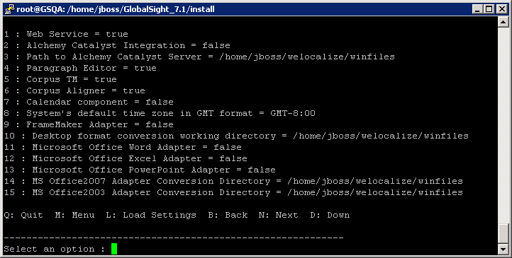
Click D to go to the next page
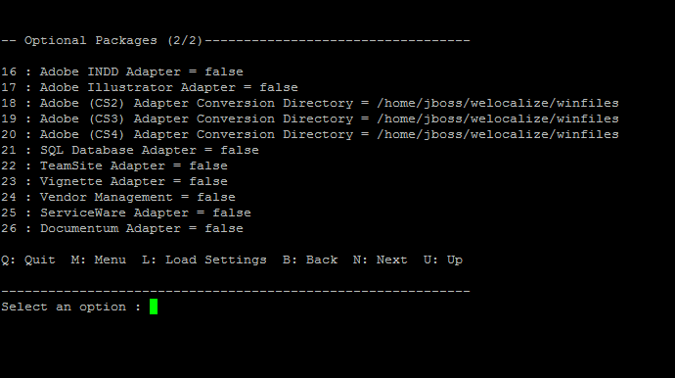
Use the table below for help with the installation parameters.
Parameter | Description
Web Service | This enables the Web Service capability of GlobalSight. Web Service does not work if it is false  Default: true
Alchemy Catalyst Integration | This enables the Alchemy Catalyst Integration capability of GlobalSight. Alchemy Catalyst Integration does not work if it is false  Default: false
Path to Alchemy Catalyst Server | The jboss user must have the write privilege to the directory you choose
Paragraph Editor | This enables the Paragraph Editor feature of GlobalSight. The Paragraph Editor does not work if it is false  Default: true
Corpus TM | This enables the Corpus TM capability of GlobalSight. Corpus does not work if it is false  Default: true
Corpus Aligner | This enables the Corpus Aligner capability of GlobalSight. Corpus does not work if it is false.  Default: true
Calendar component | This enables the Calendar capability of GlobalSight. Calendar does not work if it is false  Default: false
System’s default time zone in GMT format (i.e. GMT-8:00 for US) | This sets the time zone used by GlobalSight for all time and date calculations. This value is expressed in hours from Greenwich Mean Time. The default is set to GMT-8, which is Pacific Standard Time for the West Coast of the US and Canada  Default: GMT-8:00
FrameMaker Adapter | This enables the FrameMaker desktop publishing feature. The adapter does not work if it is false  Default: false  If this is set to true, you need to set up the converter for it. For instructions, see the Installing the Desktop Publishing Converters section of this document
Desktop format conversion working directory | The directory that the GlobalSight Desktop Application Integration feature uses for import and export. This parameter is ignored if the Desktop Application Integration parameter above is disabled  Note: The jboss user must have the write privilege to the directory you choose
Microsoft Office Word Adapter | This enables GlobalSight to work with Microsoft Word. The adapter does not work if it is false  Default: false  If this is set to true, you need to set up the converter for it. For instructions, see the Installing the MS Office Converters section of this document for instruction.
Microsoft Office Excel Adapter | This enables GlobalSight to work with Microsoft Excel. The adapter does not work if it is false  Default: false  If this is set to true, you need to set up the converter for it. For instructions, see the Installing the MS Office Converters section in this document
Microsoft Office PowerPoint Adapter | This enables GlobalSight to work with Microsoft PowerPoint. The adapter does not work if it is false  Default: false  If this is set to true, you need to set up the converter for it. For instructions, see the Installing the MS Office Converters section in this document
MS Office 2007 Adapter Conversion Directory | The directory that the GlobalSight MS Office 2007 Adapter feature uses for internal processing. This parameter is ignored if the Enable Microsoft Office integration parameter above is disabled  Note: The jboss user must have the write privilege to the directory you choose
MS Office 2003 Adapter Conversion Directory | The directory that the GlobalSight MS Office 2003 Adapter feature uses for internal processing. This parameter is ignored if the Enable Microsoft Office integration parameter above is disabled  Note: The jboss user must have the write privilege to the directory you choose
Adobe INDD Adapter | This enables GlobalSight to work with Adobe InDesign. The adapter does not work if it is false  Default: false  If this is set to true, you need to set up the converter for it. For instructions, see the Installing the ADOBE InDESIGN & ILLUSTRATOR Converters section of this document.
Adobe Illustrator Adapter | This enables GlobalSight to work with Adobe Illustrator. The adapter does not work if it is false  Default: false  If this is set to true, you need to set up the converter for it. For instructions, see the Installing the ADOBE InDESIGN & ILLUSTRATOR Converters section of this document.
Adobe(CS2) Adapter Conversion Directory | The directory that the GlobalSight Adobe InDesign CS2 and Illustrator Adapter feature uses for internal processing. This parameter is ignored if the “Enable Adobe integration” parameter above is disabled  Note: The jboss user must have the write privilege to the directory you choose
Adobe(CS3) Adapter Conversion Directory | The directory that the GlobalSight Adobe InDesign CS3 and Illustrator Adapter feature uses for internal processing. This parameter is ignored if the “Enable Adobe integration” parameter above is disabled  Note: The jboss user must have the write privilege to the directory you choose
Adobe(CS4) Adapter Conversion Directory | The directory that the GlobalSight Adobe InDesign CS4 and Illustrator Adapter feature uses for internal processing. This parameter is ignored if the “Enable Adobe integration” parameter above is disabled  Note: The jboss user must have the write privilege to the directory you choose
SQL Database Adapter | This enables the Database Integration feature of GlobalSight. The adapter does not work if it is false  Default: false
Vendor Management | This enables the Vendor Management capability of GlobalSight. Vendor Management does not work if it is false  Default: false

- Type N to go to the next page

- In Optional CMS settings:
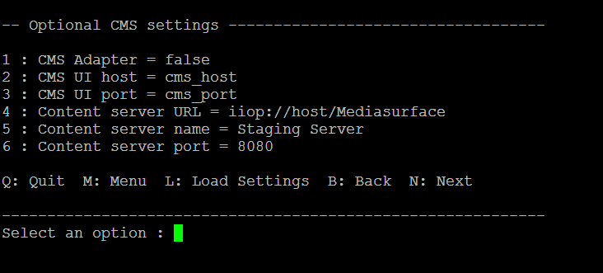
Use the table below for entering the installation parameters.
Parameter | Description
CMS Adapter | This enables the CMS integration feature of GlobalSight. The adapter does not work if it is false  Default: false
CMS UI host | The hostname of the machine where the CMS UI is running, for example “tempest”  Default: cms_host
CMS UI port | The port that is used to display the CMS UI. For example, if the CMS module is deployed in Tomcat, then typically this is 8080 by default  Default: cms_port
Content server URL | An IIOP or RMI URL that can be used to connect to the MAE (Mediasurface Application Engine). If the MAE is deployed on the machine ‘tempest’, then an example value is: iiop://tempest/Mediasurface  Default: iiop://host/Mediasurface
Content server name | The name of a “Content Server” object configured within the CMS. For example “Staging Server”, “Live Server”, and so on. GlobalSight is set up to localize content from this content server  Default: Staging Server
Content server port | The port of the specified Content Server. For example, “8080”. If JSP templates are being used, then this is typically the same as the CMS UI port  Default: 8080
- Type N to go to the next page

- Set Install Options
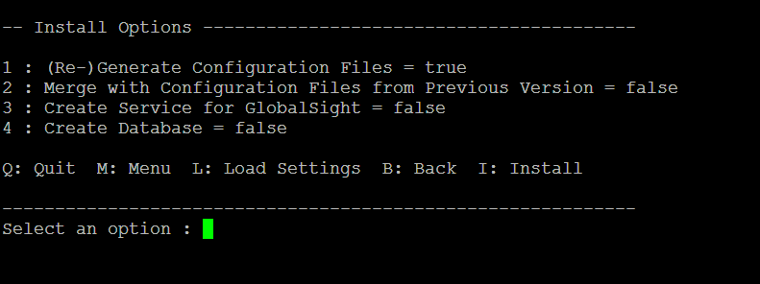
For a first GlobalSight install, set options 1, 3 and 4 above to 'true'
Note: Option 4 creates database tables for the GlobalSight application. The installer drops exiting tables, if they exist from a prior install, and creates new tables for the GlobalSight application. If this is not your first GlobalSight install, setting option 4 to 'true' causes a loss of data.
- Input I to start the installation process
After installation, press 'Enter' to continue.
GlobalSight is now installed.
Verify that there are no errors during the database creation step by viewing the console.
- Configuring the user jboss.
Switch to the user with the sudo privileges and set the file attribute for installValues.properties
Type: sudo chown jboss /tmp/installValues.properties
Set the owner of the GlobalSight system to jboss:
Type: sudo chown -R jboss /home/jboss/GlobalSight_7.1
Set the related file executable, for example:
Type: sudo chmod u+x /home/jboss/GlobalSight_7.1/jboss/startJboss.sh
Type: sudo chmod u+x /home/jboss/GlobalSight_7.1/jboss/jboss_server/bin/run.sh

Configuring the OpenLDAP Directory Server
Shut down the OpenLDAP server before configuring.
- To shut down the OpenLDAP
Get the process id by: ps aux | grep slapd
Type: sudo kill -9 <processid>
Make sure that the slapd process has been removed
- For a clean install, remove the globalsight directory, if it exists from a previous installation in /usr/local/openldap/etc/
Type: sudo rm -R /usr/local/openldap/etc/globalsight
- Go to the openldap folder
Type: cd /usr/local/openldap/etc/openldap
- Copy all configuration (*.conf and *.ldif) files to the OpenLDAP install directory and overwrite if needed
Type: sudo cp /home/jboss/GlobalSight_7.1/install/data/openldap-linux/*.conf .
Confirm that ldap.conf and slapd.conf are copied to the /usr/local/openldap/etc/openldap directory
Type: sudo cp /home/jboss/GlobalSight_7.1/install/data/openldap-linux/*.ldif .
Confirm that addCustomer.ldif, globalsight.ldif and vendor_management.ldif are copied to /usr/local/openldap/etc/openldap directory.
- Copy the globalsight directory to the OpenLDAP directory
Type: sudo cp -R /home/jboss/GlobalSight_7.1/install/data/openldap-linux/globalsight /usr/local/openldap/etc/
- Write the DB CONFIG file for the GlobalSight
Type: sudo cp /usr/local/openldap/etc/openldap/DB_CONFIG.example /usr/local/openldap/etc/globalsight/data/DB_CONFIG
If needed, edit the cache size for the DB_CONFIG. This is optional
- Make sure that the /usr/local/openldap/sbin is in the PATH
Type: echo $PATH
/usr/local/sbin:/usr/local/bin:/usr/sbin:/usr/bin:/sbin:/bin:/usr/games:/usr/local/mysql/bin:/usr/local/java/jdk1.6.0_07/bin:/usr/local/openldap/sbin
- Enter the following commands to import the ldap configuration files:
Type: cd /usr/local/openldap/etc/openldap
Type: sudo /usr/local/openldap/sbin/slapadd -l globalsight.ldif
Type: sudo /usr/local/openldap/sbin/slapadd -l vendor_management.ldif
- Set the file attribute for the data created
Type: sudo chown openldap -R /usr/local/openldap/etc/globalsight/data
- If you have not set the start service for OpenLDAP, go to the directory (GlobalSight_7.1/install/data/linux)
Type: cd /home/jboss/GlobalSight_7.1/install/data/linux
Type: sudo cp slapd.sh /etc/init.d/
Type: sudo chmod u+x /etc/init.d/slapd.sh
Remove the previous start service for slapd.sh
Type: sudo update-rc.d -f slapd.sh remove
Add the start service for slapd.sh
Type: sudo update-rc.d slapd.sh defaults 98
- You can now start the OpenLDAP server
Type: sudo /etc/init.d/slapd.sh start

Configuring GlobalSight Web Services (optional)
This feature provides a Web services API that allows any client, regardless of implementation technology or operating system, to connect and exchange data with GlobalSight.
- Log in to the GlobalSight superAdmin account
- Click the "Remote IP Filter for Webservices" link
- Click New to add the remote IP address information
For example:
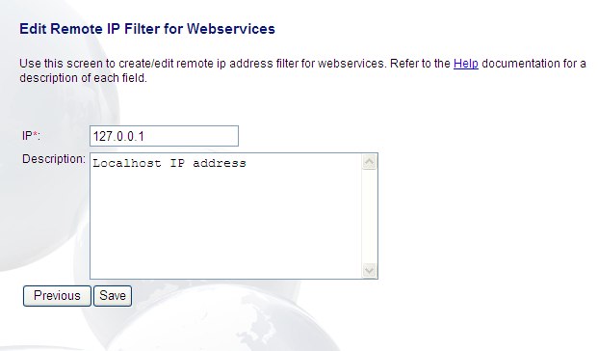
Note: You can use an asterisk (”*”) as a wildcard in place of the last IP address parameter. For example, the IP Address 192.168.30.* allows all network IP addresses that begin with 192.168.30 to use GlobalSight web services
- Click Save

Installing the Aligner (optional)
Alignment is the process by which segments in previously translated files are matched with one another to create translation memory. This process is partially automated, in that the language resource is responsible for confirming the alignment between source and target segments.
This process allows translation memory to be rapidly created from content previously translated.

Pre-requisites
JDK 1.6.0_07 or later must be installed before installing the Aligner.

Installation
- Unzip the galign-installer.zip to a temporary location
For example: /usr/local/galign
- Go to the temporary location where you unzipped the installer
  - For Windows: Run setup.exe
  - For Macintosh: Double-click the galign-installer.jar
  - For UNIX: Run “java -jar galign-installer.jar”
Galigner has now been installed.

Configuring Samba (optional)
Configure Samba in order to set up Office 2003/2007 or Adobe InDesign converters.
Ensure that Samba has been installed.
Type: sudo apt-get install samba
- Switch to the user with sudo privilege, and edit the /etc/samba/smb.conf file:
[global]
workgroup=workgroup
server string=ubuntu server
security=share
encrypt passwords=true
smb passwd file=/etc/samba/smbpasswd
guest ok=yes

[<Name>]
path=<path>
public=yes
writable=yes
create mask=0777
directory mask=0777
< Name> is the name of your shared directory, and the <path> is the directory that you want to share.
Note: the jboss user must have the read/write privileges for this folder
A sample smb.conf file looks as follows:
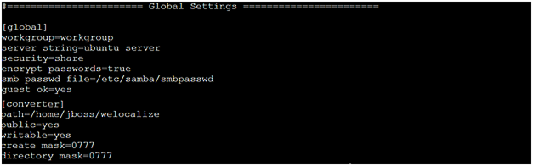
- Re-start Samba to make the configuration take effect
Type: sudo /etc/init.d/samba restart
- Verify your Samba configuration
Type the following link in Windows explorer:
\\<IP address for ubunut>\<Name>
e.g. \\192.168.29.29\converter
- Add the user nobody to the jboss group to make sure that the windows user has the write privilege to the converter file
Type: sudo usermod -a -G jboss nobody

Converters for Windows (optional)

Pre-requisites
The converters must be installed on the Windows server, since the corresponding applications work on the Windows server only.

Server
The Microsoft Office Converters require a dedicated Windows XP/2003 Server Machine with the configuration below.

Hardware
Windows Compatible Server with 1 CPU Min, 2Ghz or faster Intel processor(s) only unless otherwise approved by GS
Memory Requirements: 512 MB RAM Min.
Hard drive with at least 2MB of free space for each conversion software component and at least 30-40 MB per document format application (check with each application for specific disk space requirements)

Operating System: Microsoft Windows XP/2003 Server

Additional Software For Converters
Microsoft DotNet Framework 2.0
Microsoft Office 2003/2007. (For MS Office Converters. 2003 and 2007 should be installed on separate machines.)
Adobe InDesign CS2/CS3 and Illustrator (InDesign CS2 and CS3 should be installed on separate machines)
Adobe FrameMaker
The Windows machine must be configured using NFS to have Read and Write access from the server on which GlobalSight is running.
The GlobalSight Microsoft Office Conversion Services use the Microsoft office adapter and the .NET framework described above to import and process Word, Excel, and PowerPoint files. Each Office format has its own converter service that can be installed separately from the others. All formats, however, require installation of the .NET framework as described below.
Installing the MS Office Converters

Install .NET Framework 2.0
Download the Microsoft .NET Framework 2.0., which is also included in the GlobalSight package
Double-click the file dotnetfx2.0.exe to install the Microsoft .NET Framework
Accept all defaults and walk though the installation
Re-start the computer after the installation finishes (default)

Installing the MS Word Converter Service
The version of the Word converter should correspond to the version of the application on the machine. Different versions, for example 2003 and 2007, cannot be installed on the same machine.
Create a shared directory, referred to in this document as <ConversionDir>, which contains your source files. This should match the directory you set in the Install Wizard – Optional Packages – MS Office 2003/2007 Adapter Conversion Directory
For example: \\192.168.29.29\converter\winfiles
Under the <ConversionDir>, create a directory for the MS Office format you want to import. For example, “excel”, “word” or “PowerPoint”. “Word” will be used for the purposes of this document
Enable the Microsoft Word Adapter during the installation of GlobalSight by setting the following installation parameters:
Microsoft Word Adapter Conversion Directory: Do not use a trailing slash in the name. If the conversion directory is physically on a different computer and is being accessed over the network, do not use a mapped drive. Instead use the UNC path, for example: \\server\WINFILES.
Mapped drives do not work if the server has been set to startup automatically on reboot.
Extract conv_word.zip and double-click setup.exe to install the converter.
Install the service by executing InstallService.bat in the converter install directory.
The WordConversionService that is created is a separate Windows Service that monitors the watch directory. The service name is “GlobalSight Converter – Word 2003/2007”.
Create the registry key by executing the following command:
REG ADD HKLM\Software\GlobalSight /v MsOfficeConvDir /t REG_SZ /d <ConversionDir>
For example: <ConversionDir> will be \\192.168.29.29\converter\winfiles
REG ADD HKLM\Software\GlobalSight /v MsOfficeConvDir /t REG_SZ /d \\192.168.29.29\converter\winfiles
Note: The last value is the actual directory to use for conversion. It should not end with a “\”, nor include the format (Word, Excel, and PowerPoint) sub-directory
Go to the Services Control Panel and manually set how the service should log-on. The default is the “LocalSystem” account. If the “conversion directory” is on a separate server, then this service may need to run as a user with appropriate access rights.
Note: Open and close Word before using The Word Converter Service.
To start importing Word files, place your Word files in the GlobalSight Document Directory (or place in TeamSite, Vignette, etc.) and create File Profiles in GlobalSight using the Source File Format “Word” and the extension “doc”. Word files can be imported like any other file format from any repository. For example, you can use manual file system import, auto import, TeamSite, Vignette, etc.
Repeat this process for Excel and PowerPoint.

Error Logs
Any errors related to the MS Office converter services are logged in the EventLog. Any other errors in normal processing are logged in a file called <ms_office_format>Converter.log under the <ConversionDir>\<ms_office_format> location.

Uninstall
To uninstall the service, execute UninstallService.bat in the converter install directory.
Delete the registry key manually by executing:
REG DELETE HKLM\Software\GlobalSight /v MsOfficeConvDir
Installing the ADOBE InDESIGN & ILLUSTRATOR Converter

Installing the InDesign and Illustrator Converter
To run the InDesign CS2/CS3/CS4 and Illustrator CS2 converter, InDesign CS2/CS3/CS4 and Illustrator CS2 application need to be installed in the same machine with the corresponding converter. But CS2 and CS3 (application or converter) cannot be installed on the same machine.
Extract Adobe_CSx_Converter.zip (Adobe_CS4_Converter.zip for InDesign CS4) and double click on AdobeConverter.exe to run the converter.
Select InDesign Converter CS2/CS3/CS4 and Enter or Browse the directory that is used in GlobalSight – Optional Packages – Adobe (CS2)/(CS3)/(CS4) Adapter Conversion Directory.
Select Illustrator Converter CS2 and Enter or Browse the directory that is used in GlobalSight – Optional Packages – Adobe (CS2) Adapter Conversion Directory.

Set Converter
Click Start
Type the following link in your converter dialog
\\<IP address for ubunut>\<Name>
e.g. \\192.168.29.29\converter\winfiles

Error Logs
Any errors related to the Adobe InDesign & Illustrator converter are logged in the EventLog. Any other errors in normal processing are logged in a log file called AdobeConverter.log under the selected directory location.

Uninstall
Click Stop
Remove the Adobe Converter directory
Installing the Desktop Publishing Converters

Pre-requisites for the Adobe FrameMaker Converter
Install the Microsoft .NET Framework 2.0
Install the version(s) of Adobe FrameMaker you are using with GlobalSight.
The following are currently supported:
- FrameMaker 5.5 (or FrameMaker+SGML 5.5)
- FrameMaker 6.0 (or FrameMaker+SGML 6.0)
- FrameMaker 7.0
If installing FrameMaker5.5/6.0/7.0 for the first time:
- Open each FrameMaker prior to trying any conversions.
- Clear any installation or registration messages.
- Print a test page to verify that printing is working correctly

Installing the FrameMaker Adapter
Double-click GSFrameAdapters.exe
Click Yes to install the Adapter
Click Next on the “welcome to the Installshield Wizard For GlobalSight Frame Converter” screen
Click Yes on the “License Agreement” screen
In Custom Information, accept the first and third defaults
Enter your Company name
Click Next
On the “Setup Type” Screen
Select the version(s) of FrameMaker you want GlobalSight to Support
Choose the Destination Location for Pyxis then Click Next.
Choose the location of the Plugins directory. If you have chosen more than one version of FrameMaker, you will need to choose a location for each one. To be safe, use the Browse button to select these paths. For example:
d:\Program Files\Adobe\FrameMaker5.5\fminit\Plugins
d:\Program Files\Adobe\FrameMaker6.0\fminit\Plugins
d:\Program Files\Adobe\FrameMaker7.0\fminit\Plugins
Click Next.
Click Finish to complete the Pyxis installation.
Add the following directories:
<framemaker5.5_home>\fminit\Plugins
<framemaker6.0_home>\fminit\Plugins
<framemaker7.0_home>\fminit\Plugins
to the System PATH environment variable.
Edit each FrameMaker initialization file.
Go to the FrameMaker home directory.
Edit the maker.ini file if you are using FrameMaker5.5
or
Edit the fmsgml.ini file if you are using FrameMaker+SGML 5.5
Add the following line under the [APIClients] section:
For FrameMaker 5.5 and 6.0, add:
xml2fm=Standard, xml2fm, fminit\plugins\xml2fm.dll
For FrameMaker 7.0, add:
xml2fm=Standard, xml2fm, fminit\plugins\xml2fm.dll, structured
Open the GlobalSight Desktop Publishing Conversion Server service from the Services Control Panel and verify the following settings:
Startup Type is Automatic.
“Path to executable” is correct. For example: d:\constellation\pyxis\pyxis.exe.
On the Log On tab, “Local System account” is selected.
Leave “Allow service to interact with desktop” checked.
Restart the service.
Close the Services Control Panel.
Launch the FrameMaker application. Dismiss any registration dialogs. For FrameMaker 7.0, select the Preferences/General from the menu, and set the Product Interface to FrameMaker.
Go to the Edit the Pyxis Initialization File section below if you will not be installing Noonetime Pyxis for use with any other desktop application.
Note: Once you have successfully imported a file through GlobalSight and gotten rid of any dialogs that come up you can uncheck the “Allow service to interact with desktop” You would need to restart the Service.

Edit the Pyxis Initialization File
For example: \\192.168.29.29\converter\winfiles. This conversion directory and its subfolders match the pyxis.ini file you copied over in the step above. This is also the directory you will enter as the “Desktop format conversion working directory” in the Installing GlobalSight section below.
Edit the directory structure of the WINFILES directory to match the requirements of your GlobalSight – Pyxis integration. For example, if you are not importing Frame files into GlobalSight, delete the Frame directory.
The default structure of the WINFILES directory (see Figure 1 below) is for:
English (en_US) as source locale.
French (fr_FR) and Japanese (ja_JP) as target locales.
FrameMaker 5.5, FrameMaker 6.0,FrameMaker 7.0, as formats.
Figure 1
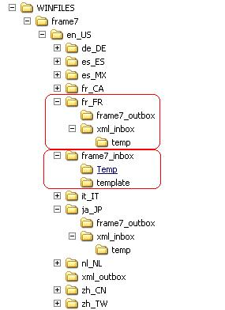
Edit the pyxis.ini file to match the configuration of your GlobalSight – Pyxis integration. For example:
Under the [EXEC] section:
Enter the correct path to the applications you are using with Pyxis.
Do not remove paths to applications that you are not be using with Pyxis. Removing these paths will cause Pyxis to fail.
Edit the [DIRS] section to match the locales and directory structure of WINFILES directory.
After editing the pyxis.ini file, verify that the actual file system directory structure matches directory structure in the pyxis.ini file.
Restart the GlobalSight Desktop Publishing Conversion Server service so the pyxis.ini file will be re-read.

Edit Regedit for FrameMaker Adapter.
From the Windows command line, run "regedit". Search "\WINNT\" and change "\WINNT\" to "\WINDOWS\" in regedit(if there is "\WINNT\"). There are only 3 places. They are:
[HKEY_CLASSES_ROOT\TypeLib\{23D7488B-418E-4777-8EFA-2ADEC6693BA8}\1.0\0\win32]
Value data="C:\WINDOWS\system32\AutoFrameServer.dll"
[HKEY_CLASSES_ROOT\TypeLib\{23D7488B-418E-4777-8EFA-2ADEC6693BA8}\1.0\HELPDIR]
Value data ="C:\WINDOWS\system32\"
[HKEY_CLASSES_ROOT\CLSID\{184A3DF9-4BE3-469B-9CCB-D7A0A2B2972B}\InprocServer32]
Value data ="C:\WINDOWS\\system32\AutoFrameServer.dll"

Test the GlobalSight – Pyxis Integration for FrameMaker7
Ensure that the GlobalSight Desktop Publishing Conversion Server service is running by opening the Services Control Panel and verifying that the service is started. If any changes were made to the pyxis.ini file since installation, restart the service.
Copy a FrameMaker file into the source content directory for the source language. This will start the conversion process.
For example, if FrameMaker is installed, and the default directory structure above is used, copy a FrameMaker file to WINFILES\frame7\en_US\frame7_inbox.
Verify that the file has been moved from the root of frame7_inbox to a new directory called Temp. Check the xml_outbox directory under en_US. An xml file with the name of the FrameMaker file should appear.
Once the XML file is finished building (verify by refreshing until file size doesn’t change), copy it to WINFILES\frame7\en_US\fr_FR\xml_inbox.
Verify that the XML file is moved from the root of xml_inbox to a new directory called Temp. Check the frame7_outbox directory under fr_FR. A file with the name of the XML file should appear. Open this file and verify that it is the same file as the original file.
Repeat as necessary for other formats.
Installing ContentManager (optional)

Pre-requisites
Mediasurface and GlobalSight must be fully installed before integration.

Integrating ContentManager

Configuring Mediasurface
- Stop Tomcat
- Backup the folder <tomcat>/webapps/cmc
- Extract the GlobalSightCmsOverlay.zip.zip file to the tomcat webapps directory
- Extract The CMCMessages.properties file from <tomcat>/webapps/cmc/WEB-INF/lib/ms-taglib.jar
Windows: cd <tomcat>\webapps\cmc\WEB-INF\lib
jar –xvf ms-taglib.jar com\mediasurface\client\servlets\CMCMessages.properties
Note: to use jar, <java_home>\bin needs to be added to the PATH variable
- Add the following to the end of the file <tomcat>/webapps/cmc/WEB-INF/lib/com/mediasurface/client/servlets/CMCMessages.properties:

# Localization
GlobalSightHost=GlobalSight Host
checkAll = Check All
clearAll=Clear All
itemId = Item Id
localize=Localize
localizeItem=Localize item <i>”{0}”</i>
pleaseSelect=Please select…
selectGlobalSightHost=Please select an GlobalSight host.
selectMediaType=Please select a media type and at least an item to be imported.

- Update the ms-taglib.jar with the modified properties file:
Windows: jar –uvf ms-taglib.jar com\mediasurface\client\servlets\CMCMessages.properties
- Remove the ‘com’ folder (and its sub-folders) from the lib directory
- Remove the old .class and .java files from the folder <tomcat>/work/Standalone/localhost/cmc/WEB-INF/templates/cmc

- Edit the file <tomcat>/webapps/cmc/GlobalSightHost.properties so that it contains an entry with the name of the GlobalSight host and its IP address
Example: GlobalSight_server=10.0.0.4

- Start the Mediasurface SyncD module
Windows: Start the “Mediasurface ms SyncD” service from the Services Control Panel.
- Start the Mediasurface MAE module
Windows: Start the “Mediasurface ms MAE” service from the Services Control Panel
- Start Tomcat.
Windows: Start the “Apache Tomcat 4.1” service from the Services Control Panel.
- Update the CMC style sheet:
  - Login to the CMC.
  - Select View > Options
  - Click on Administration tab
  - Select Colour Scheme > globalsight.
  - Click on the ‘Commit Changes’ button to update the style sheet.

- Launch the Mediasurface Java Client and login

- Select the Global > Administration menu item

  - In the Settings tab, under Web server views, type ms-localize in the text field and click Add view
  - In the Content servers tab, add a new content server. The name and port of the content server is used during the installation of GlobalSight
  - In the Sites tab, edit the existing site and add the host. The host name is the name of the machine. The name of the site is used during the installation of GlobalSight
  - In the Locales tab, add the locales that are used as target languages if they are not already in the list
  - Close the Administration window
- Select the Global > Select Site menu item. Select the site and click OK
- Select Access > Groups
  - In the Groups window, select Site Managers and click Edit
  - In the Site Managers window, in the Item type access tab, click Select All and click OK
  - Close the Groups window

- Select Access > Users
  - In the Users window, select Group > All
  - Select ‘msadmin’ from the list of users, and click Edit
  - In the User group membership tab, make sure that Site Managers is selected
  - Close the User properties window
  - Close the Users window

Configuring GlobalSight
- Run the GlobalSight installer
- In the Optional CMS settings screen, specify the Mediasurface settings:
  - CMS UI host: name of the Mediasurface machine
  - CMS UI port: the Tomcat port number, for example, 8080
  - CMS Adapter installation key
  - Content server URL: iiop://<Mediasurface machine>/<site name from step 15c>
  - Content server name: <content server name from step 15b
  - Content server port: <content server port from step 15b
- In the Install Options screen, if GlobalSight has already been installed, leave the “Generate and Copy Configuration Files” check box selected, and de-select all other check boxes
- Click Install and then Click Quit when finished
- Start GlobalSight

Setup

Setting up a user
- Login to GlobalSight
- Click on the My Account link in the upper right-hand corner
- On the Edit My Account – Basic information screen, click the Account Options button
- On the Account Options screen, enter your CMS user name and password
- Click Done
- On the Edit My Account – Basic information screen, click Save

Importing a file into GlobalSight
- Select the Content Management > Console menu item in GlobalSight
- Browse the CMS for the content to import into GlobalSight. Click the checkbox, and then click the Localize tab
- In the Localize tab, the content items are grouped by media-type. Select the group and items, and then click the Localize button
- In the pop-up window, select the GlobalSight file profile, and then click OK
The file is imported into GlobalSight

Note: All normal content items are of the type application/x-Mediasurface,) and use a file profile with an XML file format and a UTF-8 encoding. Pop-up editor users can see a dynamic preview of the content item, using the Standard display template, by clicking the “Dynamic Preview” link. A revision is created in the CMS each time a user does a dynamic preview.

At workflow completion and export, the content item is written back to the CMS and signed off to the next version.

Configuring GlobalSight for Auto-Import (optional)
This feature allows files to be automatically imported into the system.

Pre-requisites
Set up GlobalSight with at least one Localization Profile and one File Profile so that the settings you enter below can accurately reference GlobalSight objects for processing and routing.

Set Auto-Import Parameters
Edit the file <application_home>/autoFileImport.properties
Use the table below to enter the correct parameters for your GlobalSight installation.
Note: Changes to this file require a GlobalSight restart.
Parameter | Description
disableAutoImport | Flag (true or false) to enable the entire Auto-Import feature. If it is false, then no directories are watched for auto-import  Default: false
pollingFrequency | The polling frequency in seconds. This is how often the GlobalSight polls the directories for changes  Default: 60
BatchSize | This determines the number of files to import in a batch when changes have been detected. This only matters if the associated Localization Profile uses Batch instead of WordCount to determine job size. For example, if when polling, it has been determined that three files have changed, either three batches containing one file each can be sent, or one batch containing three files.  The values allowed are “one” or “all.  Default: one
AssumeUnencounteredFilesAreNew | Flag (true or false) to tell GlobalSight whether to consider files in a directory that has not previously been scanned new. For example, if the directory en_US\pressReleases exists and has five files before the first time GlobalSight is run, then all five of those files are identified as new files and imported if the property is set to true. If the property is set to false, then the five files are not imported unless they are modified later. A sixth file added to the directory is identified as new and imported regardless of the setting.  Default: true

Specifying directories to watch
Edit the file <application_home>/autoFileImport.map
Enter one line for each directory that you want to watch. Enter each line in the format:
<directory> | <jobNamePrefix> | <FileProfileName>
Where:
<directory> is the directory that you want to watch. Watching is recursive, so sub-directories are also be watched
<FileProfileName> is the File Profile in GlobalSight that corresponds to the files in this directory
For example, the entry:
en_US\pressReleases | PressReleases | My_en_US_HTML_Files
specifies that the directory <globalsight_docs>\en_US\pressReleases will be watched by GlobalSight for new and changed files. The files imported from this directory will be processed as specified in the GlobalSight File Profile “My_en_US_HTML_Files”.
Preparing documents for import
Create the document directory that you entered during the installation of the GlobalSight files
For example: /home/jboss/welocalize/docs
Create a sub-directory where you store your source files
For example: /home/jboss/welocalize/docs/en_US
Put the documents you want to import in this director.
If your source language is different, replace en_US with your source language locale
For example: es_MX.

Start and stop procedure
Use this procedure to start GlobalSight. The procedure starts and stops Jboss only, since all other GlobalSight components run as automatic services and are therefore already running when the machine is started.

Start GlobalSight in Service Mode
Type: sudo /etc/init.d/globalsight start
Check the GlobalSight.log in /home/jboss/GlobalSight_7.1/logs directory. If GlobalSight started successfully, you will see the message below in GlobalSight.log:
----------- GlobalSight is now ready to accept logins.

Stop GlobalSight in Service Mode
Type: sudo /ect/init.d/globalsight stop

Start GlobalSight in Console Mode
Run <GlobalSight Server Directory>/jboss/startJboss.sh.
Wait until the following sentence come up:
-----------JBOSS -- GlobalSight started ------------

Stop GlobalSight in Console Mode
Press <Ctrl + C> in the JBoss Console

Logging in to GlobalSight
Open Internet Explorer and go to: http://server.domain.com:port/globalsight
"server.domain.com" is the value entered for " J2EE App Server Hostname or IP Address"
"port" is the value entered for " J2EE App Server HTTP port"
Username: gsAdmin
GlobalSight Administrator user.
Password: password
The password for the GlobalSight Administrator user.

Uninstalling GlobalSight
To uninstall the GlobalSight components, follow the steps below in the order listed. All uninstall procedures assume that GlobalSight is not running.

Uninstall the Application Service
Stop GlobalSight
Type: sudo /ec/init.d/globalsight stop
Type: sudo update-rc.d globalsight remove
Remove the GlobalSight directory

Uninstall the OpenLDAP Directory Server
Remove the directory /usr/local/openldap

Uninstall JDK
Remove the directory /usr/local/java

Uninstall MySQL
Stop MySQL
Type: sudo /etc/init.d/mysql.server stop
Remove the directory /usr/local/mysql
Remove the configuration file /etc/mysql/my.cnf

Cleanup the system PATH variable
Edit the file /etc/profile and remove related PATH variable.

